Project Design Phase-II Technology Stack (Architecture & Stack)
Date | 28 February 2026
Team ID | LTVIP2026TMIDS36731
Project Name | Heart Disease Analysis
Maximum Marks | 4 Marks
Technical Architecture:
The Deliverable shall include the architectural diagram as below and the information as per the table1 & table 2

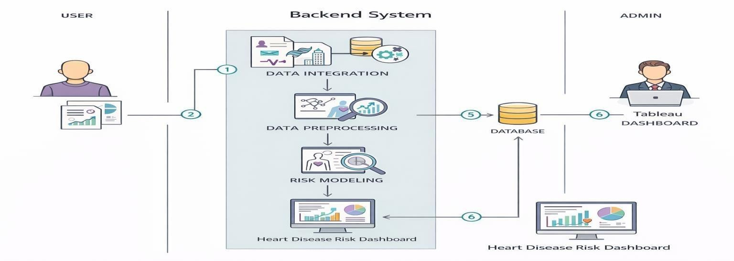
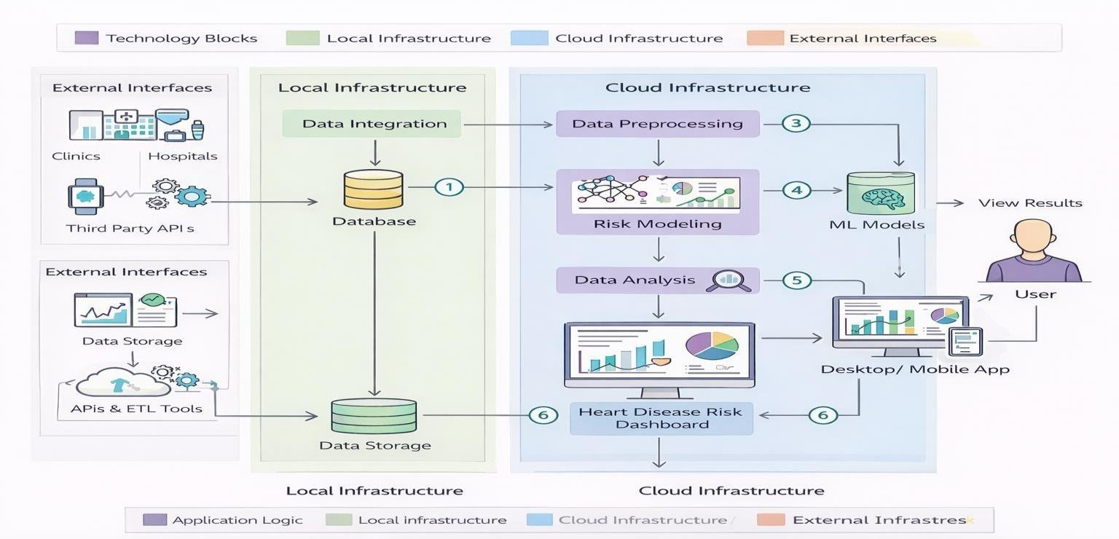
S.N o | Characteris-cs | Descrip-on | Technology
1 | OpenSource  Framework s | The applica@on uses open datasets and visualiza@on tools to analyze iPhone sales and market trends in India. Tableau supports integra@on with open data formats for analy@cs. | Tableau Desktop, CSV/  JSON data formats
2 | Security  Implementa@o ns | The system ensures secure access to dashboards through Tableau Public/Server permissions. Data files are stored securely and access is controlled at the plaQorm level. | Tableau authen@ca@on,  Access control, HTTPS
3 | Scalable  Architecture | The architecture supports scalability by handling large datasets and mul@ple visualiza@ons efficiently through Tableau’s in-memory engine. | Tableau Hyper Engine
4 | Availability | The dashboards are available online through Tableau Public/Server, enabling access any@me through a web browser without local installa@on. | Tableau Public / Tableau Server
Table 1:
Component | Tool / Technology | Purpose
Data Source | CSV, JSON files | Heart Disease Analysis data
Visualiza@o n | Tableau Desktop | Crea@ng interac@ve dashboards and stories
Storage | Google Drive / Local System | Storing raw and processed datasets
Collabora@o n | Google Docs, Slack | Team communica@on and report wri@ng
Deployment | Tableau Public / Tableau Server | Dashboard sharing and stakeholder access
Table 2: Applica-on Characteris-cs

S.N o | Characteris-cs | Descrip-on | Technology
5 | Performance | Performance is op@mized using data extracts, filters, and efficient visual rendering to ensure fast dashboard loading and smooth interac@on. | Tableau Extracts  (.hyper), Caching

